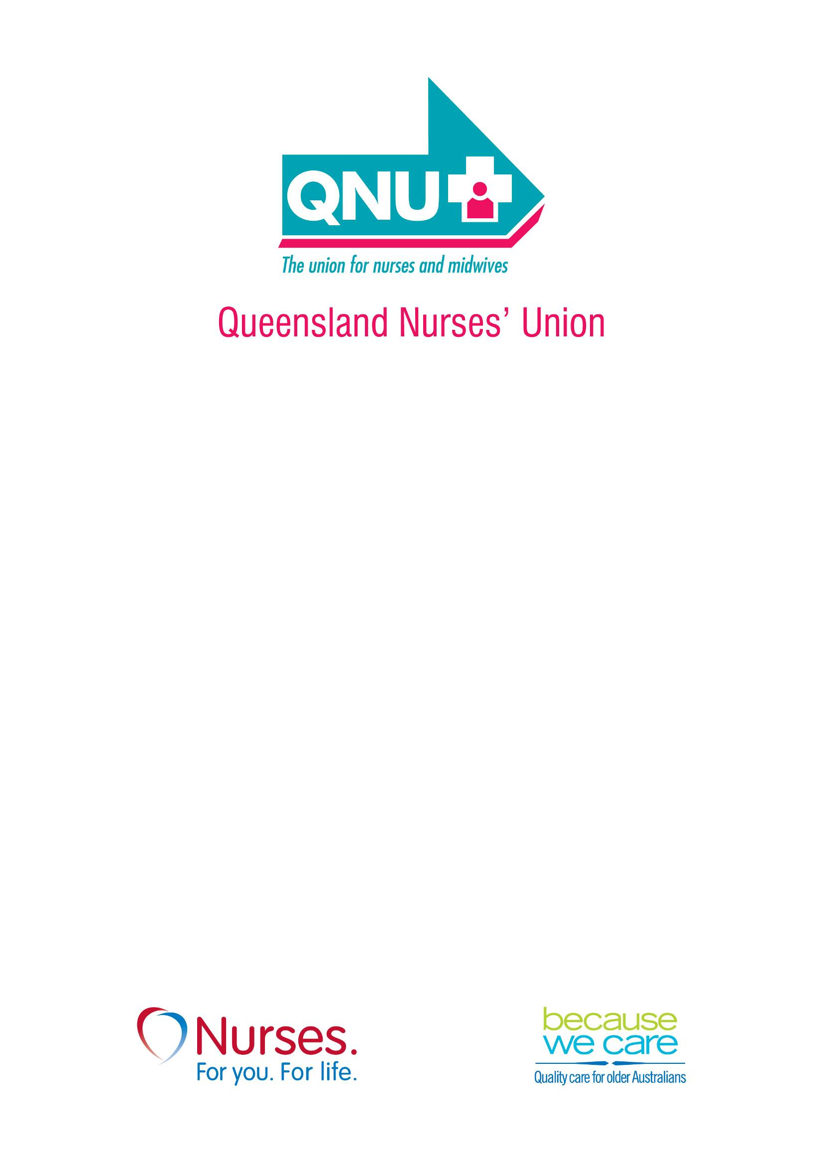

Submission to the
Australian Human Rights
Commission

26 November, 2010

Introduction

The Queensland Nurses’ Union (QNU) thanks the Australian Human Rights Commission for providing this opportunity to comment on federal protection from discrimination on the basis of sexual orientation and sex and/or gender identity.
The QNU - the union for nurses and midwives - is the principal health union in Queensland. The QNU covers all categories of workers that make up the nursing and midwifery workforce in Queensland including registered nurses, registered midwives, enrolled nurses and assistants in nursing who are employed in the public, private and not-for-profit health sectors including private hospitals and aged care facilities.
Our more than 43,000 members work across a variety of settings from single person operations to large health and non-health institutions, and in a full range of classifications from entry level trainees to senior management. The vast majority of nurses and midwives in Queensland are members of the QNU.

Protection from Discrimination

Our submission centres on a case study of one of our members in a same sex relationship who applied for paid parental leave as the primary care-giver to a surrogate child. The employer initially refused access to paid leave, so the QNU, on behalf of the member lodged a complaint with the Queensland Anti-Discrimination Commission. We use this case to highlight some of the difficulties lesbian, gay, bisexual, trans and intersex (LGBTI) people face in these matters. Indeed this case demonstrates how heterosexuals can also face discrimination in similar circumstances.

The QNU supports extending Commonwealth discrimination laws to include prohibiting discrimination on the basis of sexual orientation and sex and/or gender identity. We believe that there should be specific provisions to address direct and indirect discrimination that arises in cases where same sex couples seek access to paid parental leave, particularly given the federal government now has a scheme in place to fund this leave. We would hope that other workers in a similar situation are not forced into pursuing anti-discrimination claims to gain access to parental leave as happened with our member.

Case Study

An experienced nurse in a same sex relationship has been employed in the public sector for around 5 years. The couple decided to have a child and, earlier this year, entered a surrogacy agreement with a woman. The child was born late in 2010 and the couple decided that the nurse would be the primary care-giver of the child after the child’s birth. The nurse sought approval to take 38 weeks’ unpaid leave and 14 weeks’ paid leave as the primary care-giver from the approximate date of the child’s birth.
In late 2009, the nurse informed his manager that he and his partner were attempting to have a child through surrogacy. In mid 2010, the nurse sought information on the type of leave available for him to care for the child after the birth. The employer advised him that he was not entitled to ‘maternity’ leave and that he could apply for adoption leave pursuant to the organisation’s Parental Leave policy. Alternatively, he could apply for one week’s spousal leave or 52 weeks’ unpaid spousal leave if he was the primary care-giver of the child.
The nurse could not apply for adoption leave as he was not adopting the child for a number of reasons including that it is not lawful for same-sex couples to adopt children in Queensland. He could have applied for spousal leave as the primary care-giver but felt that this was unfair because he would only receive one weeks’ paid leave compared to other employees who could access fourteen weeks’ paid leave in the same circumstances.
The nurse then requested special consideration to access fourteen weeks’ paid parental leave.

The employer did not approve the request, on the grounds that:
- if he was the biological father and the primary care giver of his child he could access 52 weeks unpaid leave;
- parental leave does not include an entitlement to paid leave;
- paid leave can only be accessed if the employee is eligible for maternity leave, adoption leave or spousal leave;
- fourteen weeks’ paid maternity leave is only available to female employees and therefore not available to the nurse;
- fourteen weeks’ paid adoption leave is available to an employee who adopts a child and is a primary care giver of either gender but because the nurse was not formally adopting his child he was not entitled to paid adoption leave;
- one week’s leave paid spousal leave is available to an employee who presents a medical certificate which states the expected date of birth of the child for whom they have accepted responsibility and therefore the nurse may have been entitled to paid spousal leave.
Contravention of the Queensland Anti-Discrimination Act 1991 (the Act)

On behalf of the nurse, the QNU made a complaint to the Queensland Anti-Discrimination Commission (QADC) contending that:

the employer’s decision to refuse the nurse fourteen weeks’ paid leave and 38 weeks unpaid leave to be the primary care giver after the birth of his child was direct discrimination within the meaning of s.10 of the Act, and that

the employer’s decision to refuse the nurse fourteen weeks paid leave to be the primary care giver after the birth of his child was indirect discrimination within the meaning of s.11 of the Act.

The Union argued that the employer’s policy limited paid parental leave to the following types of employees and discriminated against those that did not fall within these categories:

    - women who have given birth to the child that is to be cared for; and
    - women or men who are the primary care giver of a child who has been adopted.

The Parental Leave policy, therefore, had the capacity to discriminate against:

  - Heterosexual men who are the primary care-giver of their child;
  - Lesbian women who are the primary care-giver of their child, which they did not give birth to;
  - Employees of either gender who are the primary care giver of an employee born out of a surrogacy arrangement;
  - Other primary care-givers who are not parents but are still the primary care-giver of a child after the child’s birth, such as grandparents.

The complaint was made as both a representative complaint pursant to Chapter Seven of the Act but due to the need to expedite the processing of the complaint because of the impending birth of the child, it was only accepted as an individual complaint by the QADC.

Resolution of the Case

The parties settled the matter prior to conciliation. The employer agreed to pay the nurse 14 weeks paid ‘special leave’ equivalent to his entitlement under the Parental Leave policy and agreed to allow him access to further unpaid leave.

